Procedure
For this evaluation, we have 8 participants. We tested the functionality of the class registration process with two tasks:

Task 1:
You are an AHCP student who is trying to register for 3 classes, AHC 603, AHC 604, and AHC 621 for Spring 2027.

Task 2:
You decided that you don’t want to continue taking AHC 605 class for this Fall 2026 semester. You want to drop it.

We recorded how long each participant took to complete each task. Then we had a post evaluation survey to ask the participants about their thoughts. After the survey, we had a short open-ended discussion on the current design.

The survey questions includes:
- The interface is easy/hard to use.
  - 1 (hard) - 5 (easy)
- The interface is understandable.
  - 1 (disagree - 5 (agree)
- The registration process is understandable.
  - 1 (disagree) - 5 (agree)
- How fast/slow is the process?
  - 1 (slow) - 5 (fast)
- From 1 to 10, how satisfied are you with the current design?
  - 1 (dissatisfied) - 10 (satisfied)
- Do you have any suggestions for improvement?
- Do you have any additional feedback?

The first four questions are on a 5-point Likert scale. The fifth question is also a Likert scale but with a range of 10 points. The last two questions are open-ended, the participants could either type or sign their answers.

Results
Test Observations
The participants were able to complete the tasks much more quickly than the last version of our prototype. Unlike last time, the participants did not go back and forth between pages. In both tasks, all of the participants were able to complete the task without getting distracted. The participants did not seem to struggle with the tasks. Some participants took more time looking at a page then moving on to the next step. Overall, the number of steps to complete each task is about the same.

Time
The participants took on average 1 minute to complete the first task. The lowest time was 45 seconds, and the highest time was 1 minute and 32 seconds. The participants took on average 18 seconds to complete the second task. The lowest time was 15 seconds, and the highest time was 25 seconds.

Task 1 Time | Task 2 Time
00:45 | 00:15
01:32 | 00:25
00:52 | 00:17
01:03 | 00:16
00:57 | 00:20
00:48 | 00:16
01:14 | 00:19
00:53 | 00:18
Average Time | Average Time
01:00 | 00:18

Survey results
The participants found the interface is mostly easy to use with an average of 4.38. 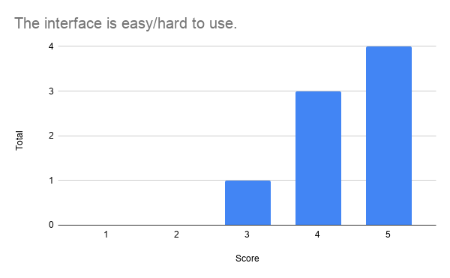

The participants found the interface is mostly easy to use with an average of 4.38. 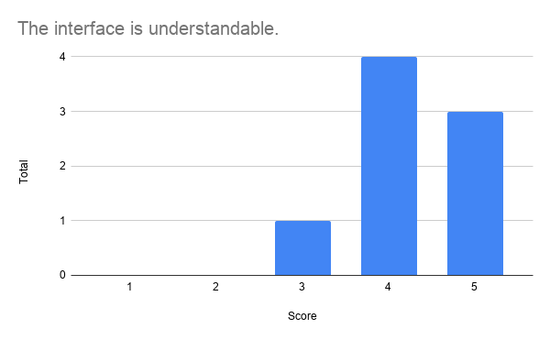
The registration process was rated as somewhat understandable with an average of 4.38. 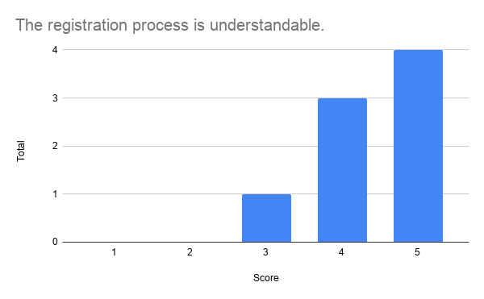
Participants viewed the registration process as somewhere in between fast and slow. The average is 4.5.
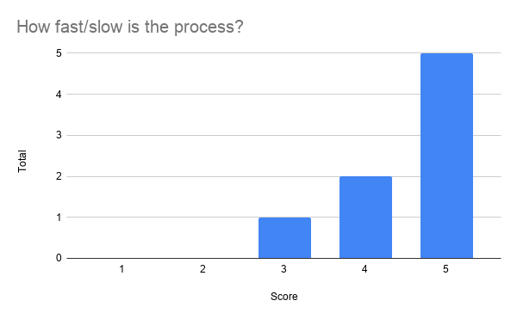
The participants’ design satisfaction rating has an average of 8.63.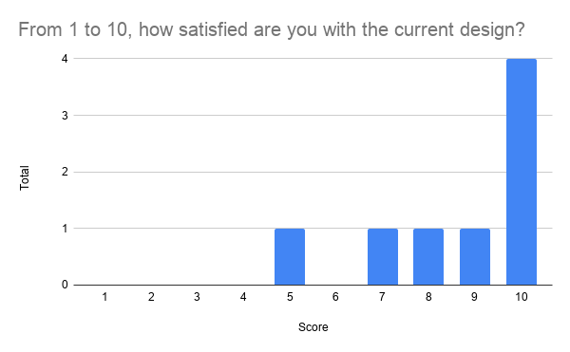
Feedback
Overall, the participants had a more positive reaction to the prototype compared to last time. The feedback were more positive. There were no explicitly negative feedback. Some important quotes are “This is less distracting then Workday! It's easier to read the important stuff”, “The overall experience was smooth and easy to understand. The design is clean and the process works well.”, “Overall I think it is a great process, It was very clear what I needed. I liked the size of the fonts. Instead of hunting it was clear.” These feedback shows that the participants like overall design and that it shows important information more clearly. There were some suggestions such as adding dark mode to increase visual accessibility and changing the color of the drop button to red instead of blue.

Discussion
The participants performed better with this prototype compared to last time. Overall, the participants scored highly on each survey item and gave positive feedback. The feedback emphasized on clarity and ease of finding important information. The satisfaction rating’s average is 8.63. This means our current design has more potential to improve.

Future Actions
Based on the feedback of the participants, we can work on adding more accessibility features such as dark mode. Currently, WorkDay only has the class registration feature. We could expand WorkDay to include other features such as an academic plan section or a financial aid section. One of our biggest limitations of this study is that our participants are not representative of the whole Gallaudet community. We do not have tests with people who are DeafBlind, low vision, have mobility disabilities, and etc. We also need to interview more users to better understand their needs. Our user testing focuses on how the users feel about the current design and has limited opportunities to be more deeply involved in designing. This can create a bias in our design to be more favorable to people who can see.

Takeaways
We found that by using the participants’ feedback from our last testing, we were able to improve our design. The quantitative and qualitative data shows that improvement. This teaches us that we need to include users in the design process to ensure that we are designing for the users and not for ourselves. We noticed that it is difficult to get participants to give feedback. Often, they want to put N/A for the open-ended questions. This observation teaches us that we need to work on improving our evaluation design to make it easier for the participants to give better feedback. For example, we could ask more specific questions, instead of general questions.

